

The Lighthouse
Zion & Trinity Lutheran Churches
950 Huron
St. Ignace, MI 49781

Address Service Requested

Nonprofit Org.
U.S. Postage
PAID
St. Ignace, MI 49781
Permit No. 55
Eric & Kelli Movalson
2716 W. Coon Lake Road
Howell, MI 48843
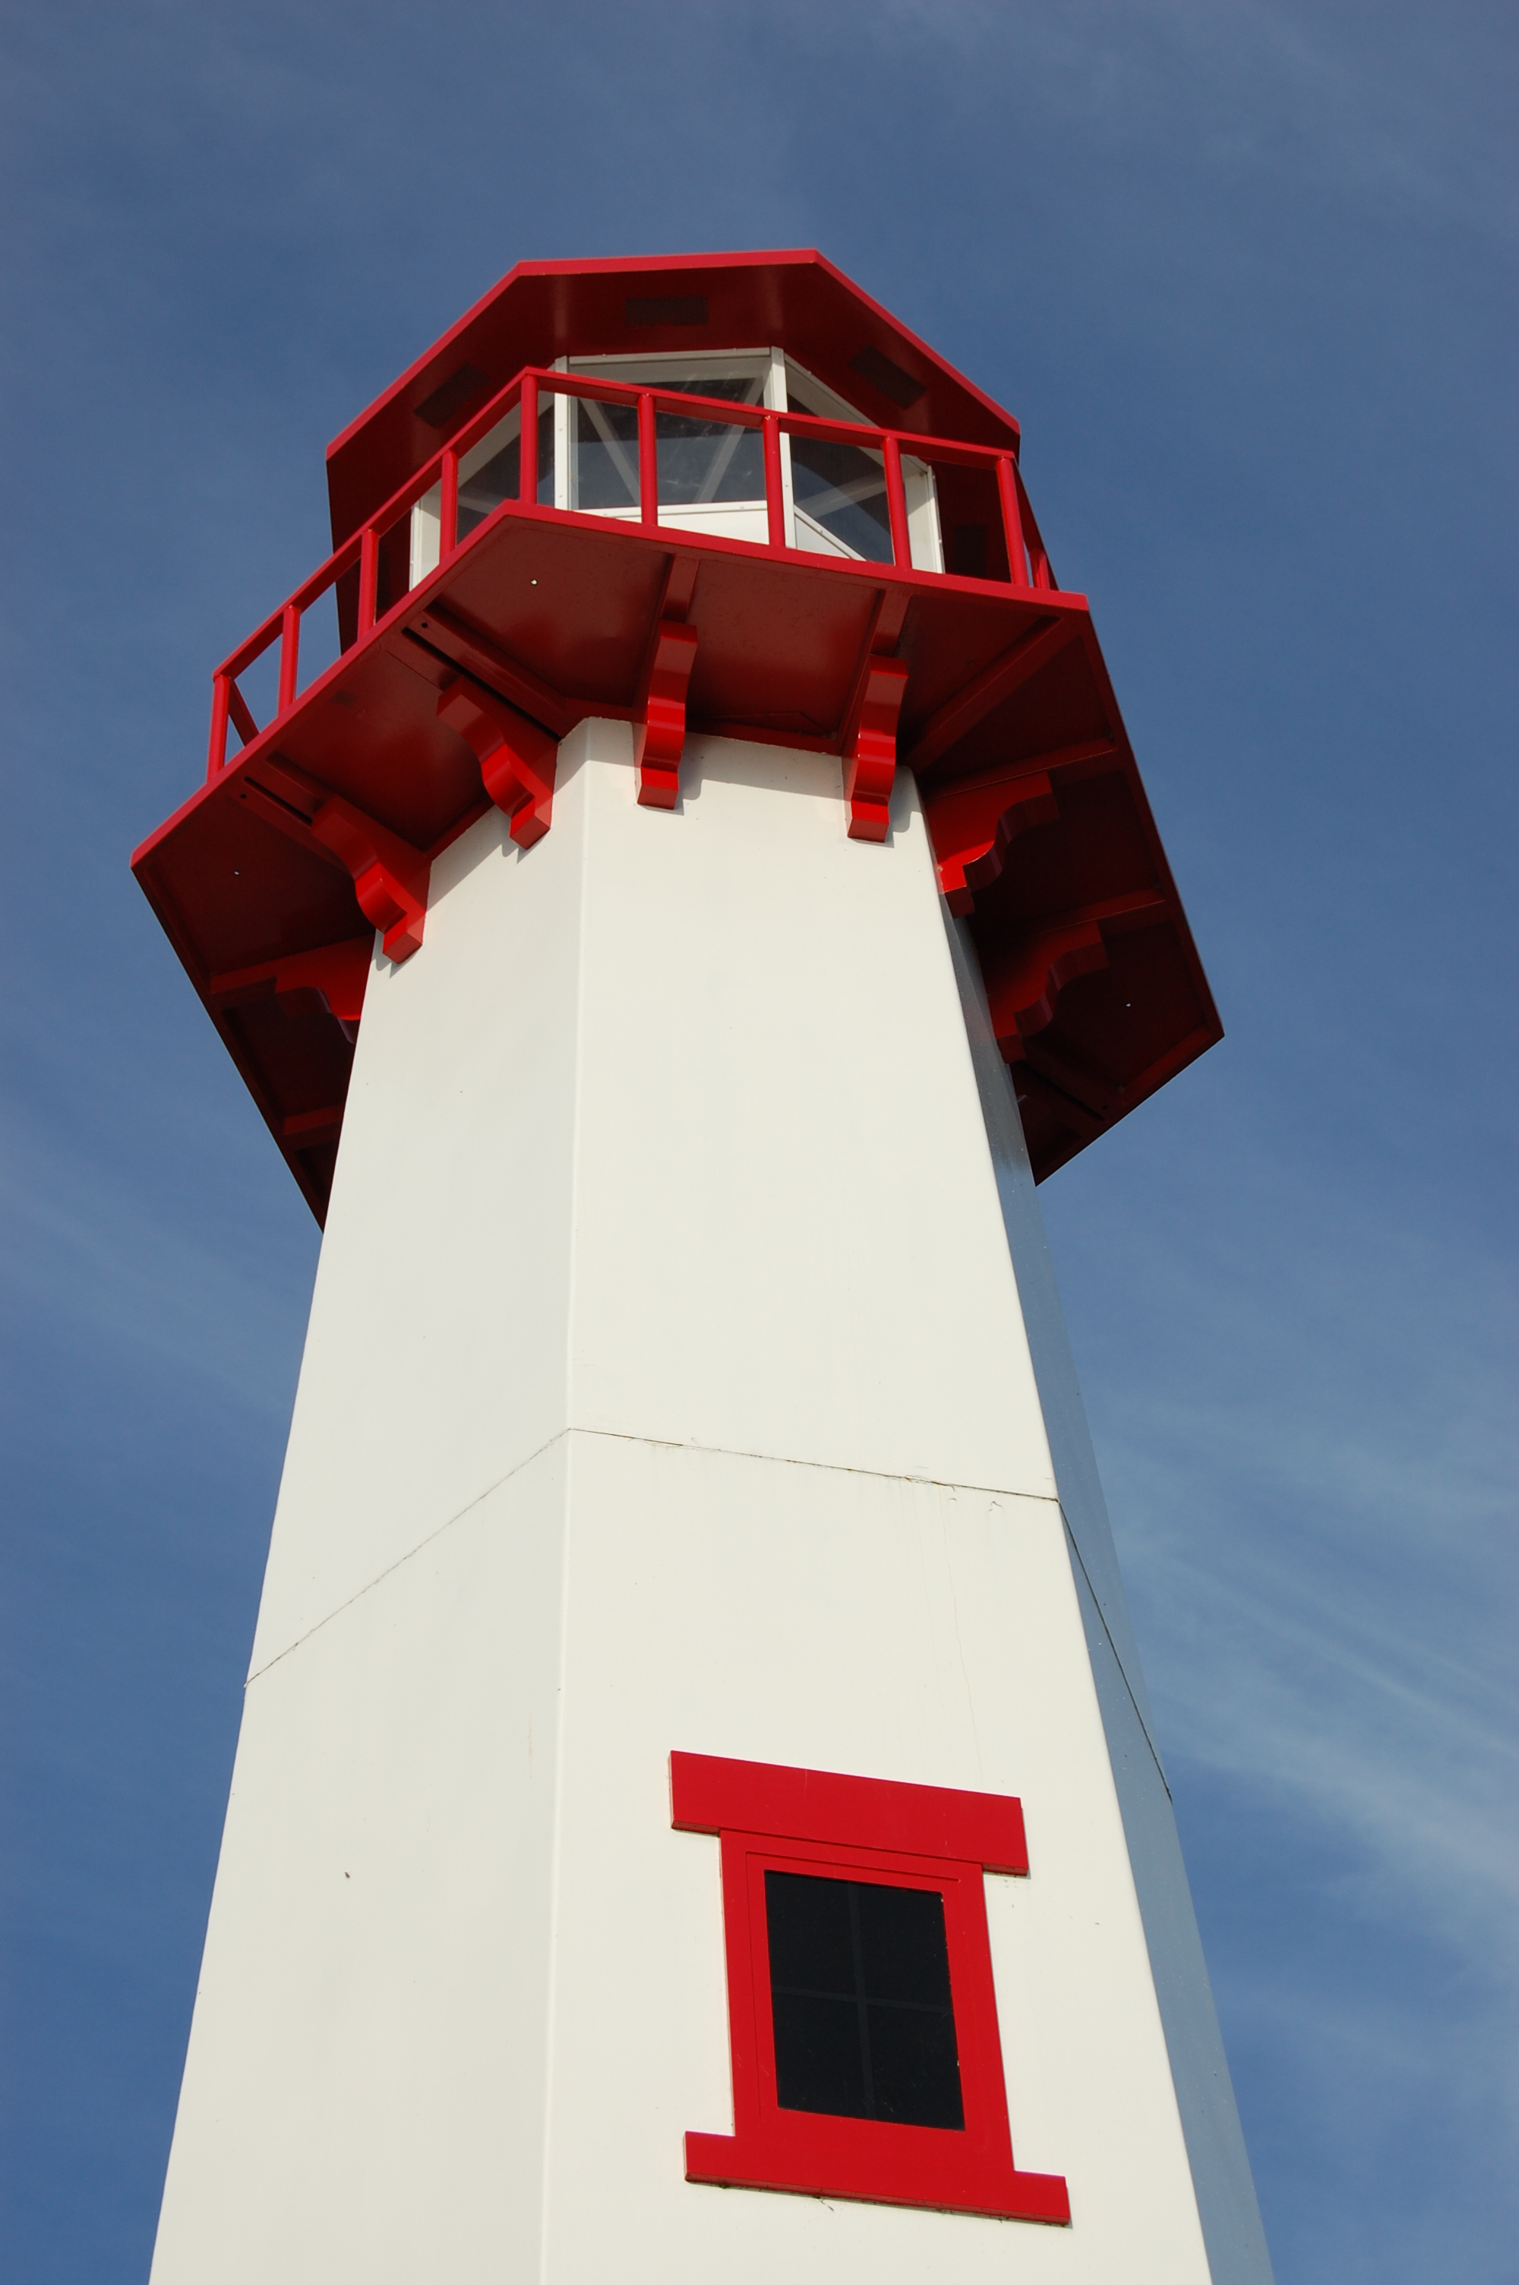
THE LIGHTHOUSE

Newsletter for August 2014

Many are asking, "Who can show us any good?" Let the light of your face shine upon us, O LORD.
Psalm 4:6

Message from Our Pastor

Well this is my last newsletter article as pastor of Zion and Trinity. I have to admit it is pretty sad. I also have to admit this is probably going to be the hardest newsletter article to write. I mean there is so much I want to say and I am going to try and limit myself to a few hundred words. So I guess it can’t all be said, I better just stick to the important stuff. First I want to say thanks. This has been an amazing four years for me, full of memories I will cherish the rest of my life. Someday I will sit around and tell my grandkids of days when I hoisted large decorated poles into the air. I will show them pictures of my wedding and tell them of the beautiful place their Grandma and I started our life together. I will tell them of the wonderful people who helped me learn how to be a pastor. The people who supported me and showed me love and forgiveness as I figured out what I was doing. The people whom I came to love and who I shared God's love with.

You know really, that is what makes leaving so hard; I genuinely came to love you people. That is both the joy and hardship of being a pastor. You are invited into people’s lives and get to know them on a real intimate level. I see people in states many others don’t, states of weakness and hurt. To see people for whom they truly are, not just this front that we so often put on for the public. I have been honored to get to know so many of you and to form those deep relationships. I have come to love the people of Zion and Trinity. It is always hard to leave someone you love. And yet I know that the love itself will not leave with me. The love I have felt from you will stay with me wherever I go. The love I have for you will not leave me as soon as I drive away.

But most important the love that inspired that love in the first place will remain. Because it is a love that comes from God. A love that never goes away. I guess those are my parting words to you all, God loves you. If you have learned anything from my time here, I hope that is it. I hope you have learned that God loves you so very, very much. That God loves you for the person you are. That regardless of what happens in this life that God’s love for you will remain. In life the people we love often come and go, but in God we find a love that is always there for us. God’s love is always there for you wherever life takes you. And someday, hopefully soon, you will have another pastor to come along and tell you that. You will love that pastor and that pastor will love you. And God’s love will continue to be known through you. I know it will. It is what you do. Love because you are loved, and you definitely are loved. And always will be.

Noisy Offering


The noisy offering for August 3rd will go for
Project Backpack.

Newsletter

The Newsletter was adopted by Mr. & Mrs. Greg Baskin


In honor of his parent’s anniversary
(Ken & Teckla Baskin)

Church History Study

Where did the church start and how did we get it to where we are today? This is an important question that unfortunately too many Christians cannot answer. If you no longer want to be one of those Christians, come and learn all about the important and fascinating history of our Church.

Church History will be finishing up at Trinity on Friday, August 3rd at 1 pm.

Vacation Bible School

From August 11th to August 14th we will be having Vacation Bible School at the United Methodist Church. We will need lots of help to have a successful program at lots of different capacities. So, if you are interested please talk with Pastor Jeremy as soon as possible. It will be from
6 to 8 pm.

Steak Dinner

We will be having our 4th Annual Steak Dinner on August 16th, from 5 p.m. to 7 p.m. You will receive steak, salad, potato, drink & dessert for a suggested donation of $10.00. Come enjoy the meal and the company!
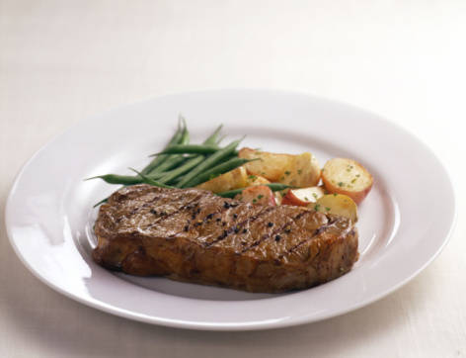

Trinity-Zion Joint Church Picnic

We will be having a “Joint Picnic” for both Trinity and Zion Churches at 1:00 pm on August 17th. It will be a pot luck held at Zion. Come and wish the Pastor good luck on his new adventure!

Lakeside Service

We will be having joint worship services with the United Methodist Church at the Red, White, and Blue Park on Saturdays starting at 7:00 pm. This will be a wonderful opportunity to enjoy the beauty of the area while worshiping its creator. Bring a lawn chair and come worship with us.

Prayer List

( If you would like someone added to the prayer list, please fill out a yellow card or call the church)


Bonnie Bergeron, Ann & Jim Dyer, Carl & Mary Belonga, Ruth Cope, LaTaunya Paquin, Christine Movalson Shaw, Lois Movalson, Phil Richel, Joy Olsen Marolf, Jim Scott, Bob Pearson, Susan Stelzer, Rob Podlesak, Judy Childs, Jackie Kallstrom, Janice Werkheiser, Judy Schlehuber Bridges, Terry Jacobson, Sandy White, Beverly Kammers, Terry Howard, Doris McFarland, Ray Burton, Janet Kanitz, Frank Feher, Phil Schaeffer, Charlie Lamoreaux, Darlene Therrian, Hallie Marshall, George Ford, Kay Allot, Wayne Chapple and Kathy Essary.

Contact Information

Pastor Jeremy Winter may be reached at 906-643-0391 or at jwinter001@gmail.com or in case of emergencies,
Pastor’s cell phone number is 712-389-2747

Church telephone: 906-643-7870 - Answering machine
The secretary will be in the office on Tuesdays and Thursdays.

To email the church is: ziontrinity950@yahoo.com
The new website is at http://zionstignace.com/home.html
- Find us on facebook at www.facebook.com/zionstignace

Roof Fund Raiser


The boilers are in and ready to go for Winter, which hopefully will not be soon. But now it is time to turn attention to the roof. We are hoping to have it done by the end of summer, but to do that we are going to need some financial help from you. Thanks to your giving during other capital campaigns we do have the bulk of what we need for the roof, so we are asking for an extra push during the next month. We need to raise about $2000 during the month of August so that our roof can be fully
replaced and paid for. Please consider
giving whatever you can, I trust that
together we can easily raise this last
little bit.

Lions Club Dinners – Fund Raiser

During September and October, we will once again have the opportunity to feed the Lions Club of St. Ignace. We serve them twice a month, on the second and fourth Monday. It is a community service and a chance to earn $250 for each meal. With the expense of a new roof for our church building facing us- what an opprotunity to earn $1000 toward that project. However, if we have to purchase all of the supples that would cut into our profit considerably. We will have a sign-up sheet in church before each of the dinners and we will need servers and clean-up persons as well.

Please don’t be shy to sign up for supplies and workers. (Cash donations are always welcome to purchase items needed.) See you at the dinners. Sincerely, Linda Wilkins

Servants for Zion

Ushers & Greeters
Aug 3 Judy Ryerse & Marialana Nygard
Aug 10 Stevan & Mary Christiansen
Aug 17 Feleppa Family
Aug 24 Mike Lehto & Mike Herman
Aug 31 Les & Debbie Therrian

Lectors
Aug 3 Richard Galor
Aug 10 Loni LaJoice
Aug 17 Judy Ryerse
Aug 24 Betsy Turf
Aug 31 Lorraine Graham

Communion Assistants
Aug 3 Faith Gaubault
Aug 10 Paul Shepard
Aug 17 Nicole Garen
Aug 24 Lorraine Graham

Acolytes
Aug 10 Donovan Insley
Aug 17 Kennedy Kammers
Aug 24 Ryan LaVake

Altar: Susan Fenlon
Money Counters: Judy Ryerse and Susan Fenlon

Zion Funeral Committee August-November

Team Leader: Linda Wilkins (643-7710)
Co-leader: Rita LaVake (906) 298-0005
Trinity Worship Families

Aug 3 The Chalmers Family
Aug 10 The Rose Family
Aug 17 The Movalson Family
Aug 24 The Gustafson Family
Aug 31 The Smith Family

Baptismal Anniversaries

August 1 Linda Wilkins

August 1 Dianne Nelson
August 10 Aubree Vallier
August 12 Debbie Therrian
August 18 Bob Brandstrom
August 18 Wendy McCluskey
August 20 Abby LaLonde
August 28 Nevaeh Wells

Anniversaries in August

August 6 Mark & Carol Elmblad
August 6 Michael & Faith Gaubault
August 10 Ernie & Stephanie Vallier
August 17 Bob & Debbie Brandstrom
August 17 Jon & Connie Olsen
August 23 Durance & Becky Paul
August 28 Charlie & Audrey Stenson
August 28 Les & Debbie Therrian

Birthdays in August

Aug 2 Amber Anderson
Aug 2 Molly Dandona
Aug 5 Cierra Barker
Aug 6 Joe Chalmers
Aug 6 Bailey Ryerse
Aug 7 Sandy Feleppa
Aug 8 Ethan Shepard
Aug 8 Craig Therrian
Aug 11 Adrian Coleman
Aug 11 Chelsey Coleman
Aug 11 Madison Coleman
Aug 13 Tyler Chambers
Aug 14 James Campbell
Aug 14 Stephanie Jenkins
Aug 14 Lana Lennington
Aug 14 Dottie Glashaw
Aug 16 Cole Garen
Aug 17 Shari Baron
Aug 19 Haley Dodds
Aug 21 Matthew Rogers
Aug 22 Donovan Insley
Aug 23 Lisa Rogers
Aug 24 Nicole Garen
Aug 25 Kristine Vallier
Aug 26 Gary Sorenson
Aug 27 Les Therrian
Aug 28 Duane Gamble
Aug 29 Gunnar Olsen
Aug 30 Michael Gaubault
Aug 30 Jim Ryerse
Aug 31 Savannah Barker

Council Meetings

Zion Council Meeting – 6:30 pm, August 13th
Trinity Council Meeting – 6 pm, August 18th

Zion’s Council Members

President: Faith Gaubault 298-1800
Vice-President Paul Shepard 984-2069
Secretary: Lorraine Graham 643-8419
Co-Treasurers: Dawn Akers 643-7552
Lana Lennington 643-6576
Nicole Garen 643-8387
Tim Idalski 643-6574
Fred Feleppa 643-6793

Trinity’s Council Members

President: Jerri Rose 292-5570
Vice-President Tracy Movalson 292-5581
Secretary: Sharon Chalmers 292-5440
Treasurer: Pega Kennedy 292-5633
Co-Treasurer: Jim Rose 292-5570
Financial Secretary: Joe Chalmers 292-5433
WELCA: Pega Kennedy 292-5633
John Kennedy 292-5633
Jim Dyer 292-5433
Lois Movalson 292-5581

Treasurer's Report for Zion
January 1, 2014 through July 12, 2014
Income:
 | Building | $2,011.00
 | General | $31,731.08
 | Thrivent Financial | $255.00
 | Trinity Share | $7,485.00
 | TOTAL |  | $42,223.08
Expenses:
 | Administration | $2,276.46
 | Benevolence | $2,620.00
 | Church Maintenance | $8,933.73
 | Education | $599.54
 | Parsonage Maintenance | $1,409.05
 | Pastoral | $24,103.31
 | Worship | $2,240.13
 | --To Building Fund | $1,999.00
 | --To LCF Loan | $500.00
 |  |  | $44,681.22
Balance: |  |  | $ (2,458.14)
***********************************************************
5/10/2014
General fund owes Building fund: |  |  | $ 85.00
General fund owes Mission Endowment fund: |  |  | $ 9,495.00
General Fund balance: |  |  | $ 1,285.11
Building Fund balance: |  |  | $ 11,240.49
Thrivent Investment Management Fund: |  |  | $ 329.47
WELCA Kitchen Fund: |  |  | $ 9,388.67
2011 -2014 Capital Campaign Donations |  |  | $ 21,425.00

Zion Lutheran Council Meeting
July 16, 2014
Present: Pastor Jeremy, Dawn Akers, Nicole Garen, Faith Gaubault, Lorraine Graham, Paul Shepard and guest Jerry Fenlon

The meeting opened at 6:35 p.m. with Pastor leading us in devotions from Martin Luther. This was followed by a prayer.

The minutes were approved with one correction.

Jerry reported that the boiler system should be completely by tomorrow. It has already been tested out a few times.

The Treasurer’s Report was approved as presented.

Pastor’s Report:

The Pastor restated his formal resignation. He expressed how sorry he was to be leaving and how much he enjoyed being here. His final day will be Sunday, August 17th. He stated that the bishop is currently in Norway but upon his return he would be helping us find a new candidate for pastor.

Vacation Bible School will be at the Methodist Church from 6 to 8 pm on April 11th through April 14th. The lessons will be taken care of by the Methodists and we will be helping with the food and crafts. Judy Ryerse is already planning the crafts. We will have sign-up sheets for those who would like to help.

We will continue with Saturday evening worship at ? pm at the Red, White and Blue Park.

Pastor stated he is continuing his Church History classes on Thursday nights and encouraged everyone to come as they provided some interesting information.

We have 5 children leaving to Fortune Lake Camp this Sunday and one student who has already gone to the teen camp.

We will need to start to get organized for the National Youth Gathering to be held next summer.

Old Business:

The 4th Annual Steak Dinner will be on August 16th from 5 to 7 pm. We will try to contact the “Motorcycle Rally” again this year. We will need to get the file from last year and start to get organized.

Marshall’s will be starting on the roof as soon as they can.

New Business:

Fred asked if there was anything that needed doing at the parsonage after the he and Liz left. Pastor stated the windows are still in need of replacement.

Pastor Jeremy stated that the warranty on the copier has run out and William’s Office Equipment wanted to know if we would like to start a service contract. We voted against this as being too expensive.

We will be supporting project backpack again this year with noisy offering for August going toward this project.

For Service Sunday on July 27th, we will again be cleaning up the downtown area, as we were “rained out” last time.

Pastor Jeremy stressed the need to continue with our confirmation class after he is gone. Dawn stated we also need to start organizing for the National Youth Gathering to be held next summer in Detroit.

Pastor stated he would teach Lorraine how to enter the newsletter onto our website and it was suggested that a few of the students should also learn.

The meeting adjourned with the Lord’s Prayer at 7:20 p.m.

Respectfully submitted,
Lorraine Graham

You Know You’re a Lutheran When
…you were little you actually thought the Reverend's first name was "Pastor."

…you hear something really funny and smile as loud as you can

…you hesitate to clap for the church choir or special music because "it just wasn't done that way in the old days."

Youth Fund Raiser

A Note from Zion Lutheran Church in Allenville:

Come and join us. Youth Fundraiser Picnic & Jamboree Saturday, August 9, 2014 at 1:00 pm at Zion Lutheran Church of Allenville. Cost: Free will donation. Picnic with BBQ pork sandwiches, hot dogs, bratwurst, potato salad, macaroni salad, coleslaw, dessert and drink (lemonade/water or BYO drink). Country Cousins Jamboree and sing-along will start at 2:00 p,m, Feel free to wear your country gear and join in. You can even bring your own clean jokes, rhymes, songs or a musical instrument if you want to help entertain. Bring your own lawn chair and join us for an afternoon of fun. If the weather doesn't cooperate, we will move into the Fellowship Hall. Raising money to send youth to the ELCA Youth Gathering Detroit Rise Up! July, 2015.



The American Cancer Society’s Relay for Life will be held Friday, August 9th, 11 a.m. to 11 p.m. at the St. Ignace Middle School. If you are interested in becoming a team member, purchasing a luminary or walking during the Relay, please call Sandy Feleppa on her cell 430-8010.

